Problem 5

Sketch *i* versus *v* to scale for each of the circuits shown below. Assume that the diodes are ideal and allow *v* to range from -10 V to +10 V.

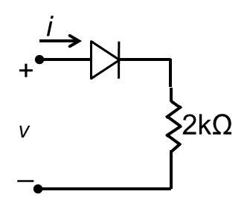 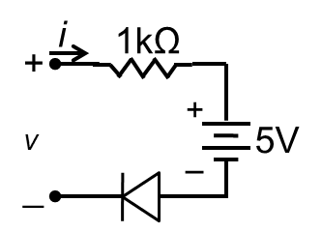

1. **(b)**

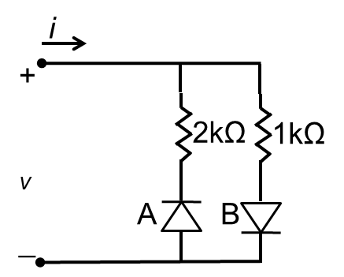 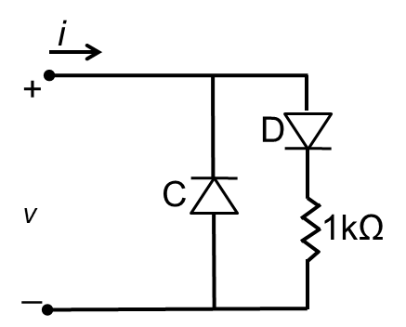

**(c) (d)**